Sprint 2 Plan, Civic Duty, Team Civic Duty, Sprint Completion 07/16/18, Revision 1, Revision Date 07/09/18

*Goals:* Designing and implementing the UI.

**User Stories:**

***User Story 1:***

As a frontend developer, I want to design and create a simple interface.

* + *Task 1:* Design a candidate/representative page (3)
  + *Task 2:* Design a state voting information page (3)
  + *Task 3:* Design a welcome page (2)
  + *Task 4:* Design a how to register/vote page (5)
  + *Task 5:* Design a address input page (2)
  + *Task 6:* Design a transition page(s) (1)
  + *Task 7:* Design a logo (2)

*Total hours for user story 1:* 18 hrs

***User Story 2:***

As a frontend developer I want to display API calls to the end user so that they can get the required information they need.

* + *Task 1:* Get API call working on React Native (5)
  + *Task 2:* Be able to connect to localhost from phone (2)

*Total hours for user story 2:* 7 hrs

***User Story 3:***

As a frontend developer, I want to develop a skeleton interface for each candidate with React Native and AdobeXD so I can make sure it's compatible with python/django.

* + *Task 1:* Get the designs to display on React Native with the AdobeXD designs (each person can do one or page) (5)
  + Task 2: Ensure that Django works with React Native/AdobeXD (4)

*Total hours for user story 3:* 9 hrs

***User Story 4:***

As a registered voter, I want to be able to browse the candidates/representatives by their party affiliation.

* + *Task 1:* Design a list of candidates/representatives page (2)
  + *Task 2:* Be able to click on desired candidate/representative (3)
  + *Task 3:* Be able to display candidate/representative information (3)

*Total hours for user story 4:* 8 hrs

***User Story 5:***

As a non registered voter, I want to be able to know how to register so I can vote in the next election.

* + *User Story 1:* Find the steps on how to register to vote (1)
  + *User Story 2:* Create a page that has the steps for registering to vote (2)

*Total hours for user Story 5:* 3 hrs

**Team Roles**

*Nick:* Frontend developer

*Daniel:* Frontend developer, Scrum Master

*Rob:* Frontend/Backend developer

*Rui:* Frontend developer

*Bryan:* Frontend/Backend developer

**Initial Task(s) Assignment**

*Nick:* user story 1, task 1, 2, 6; user story 3, task 1; user story 4, task 1;

user story 5, task 1, 2; (17)

*Daniel:* user story 1, task 3, 4; user story 3, task 1, 2; (16)

*Rob:* user story 2, task 1, 2; user story 3, task 1; user story 4, task 3; (15)

*Rui:* user story 1, task 5, 7; user story 3, task 1; user story 4, task 2 3; (15)

*Bryan:* task; user story 2, task 1, 2; user story 3, task 1; (12)

**Initial Burnup Chart**

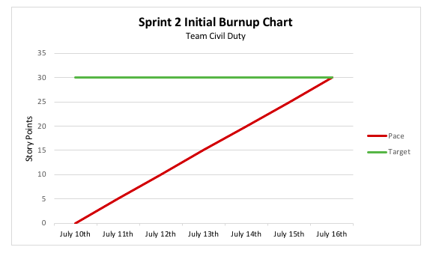

**Initial Scrum Board**

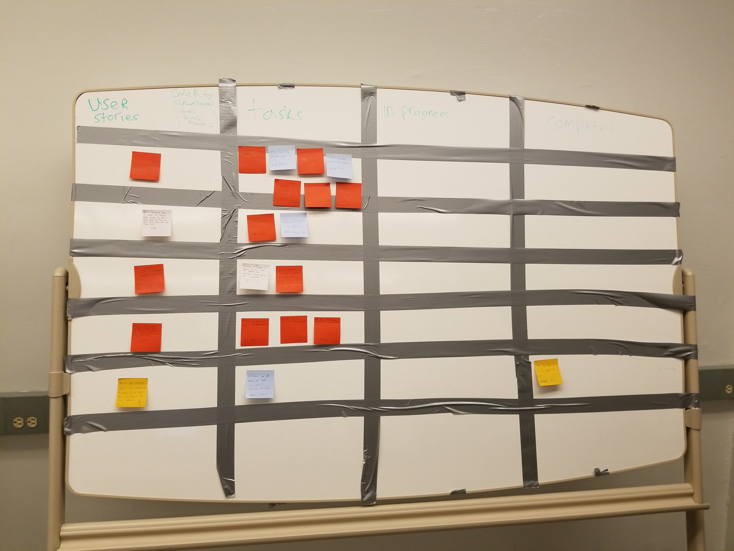

**Scrum Times:** Tuesday: 11 am, Thursday: 2 pm, Friday: 2 pm

**SCRUM Board:** See physical scrum board

**SCRUM Times:** Tuesday-11 am, Thursday-2 pm